After installing WordPress, it is time to get familiar with the system. You can do so by going through options in the left-hand bar.

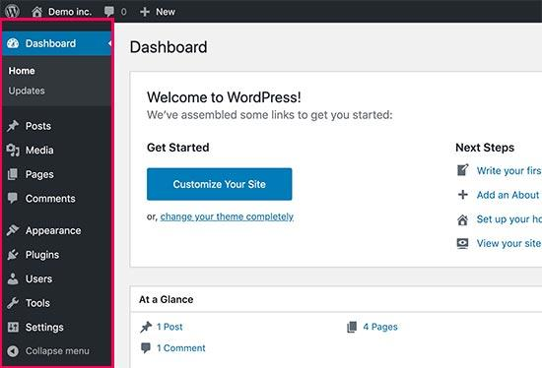

However, you may still need guidance on how to use each of the items you see in the WordPress dashboard.

The best place to start is our [free WordPress video series](http://videos.wpbeginner.com/) for beginners. These **34 videos** will guide you through the WordPress dashboard, show you how to add images, videos, audio, etc.

We recommend going through these videos as you work on your website. Don’t worry if you can’t watch them all at once. You can always come back and resume where you left off.

As you work on your website, you’ll come across terms that you may not understand. We have a handy [WordPress dictionary](https://www.wpbeginner.com/glossary/) with a list of commonly used WordPress terminology along with detailed explanation of each term.

Next, you should familiarize yourself with the [WordPress block editor](https://www.wpbeginner.com/beginners-guide/how-to-use-the-new-wordpress-block-editor/). This is where you’ll be spending most of your time when creating content for your website.

While you are at it, let’s go through some key WordPress concepts along the way.

* [Difference between Posts vs Pages in WordPress](https://www.wpbeginner.com/beginners-guide/what-is-the-difference-between-posts-vs-pages-in-wordpress/)
* [Difference between Categoris vs Tags](https://www.wpbeginner.com/beginners-guide/categories-vs-tags-seo-best-practices-which-one-is-better/)
* [How to add images in WordPress](https://www.wpbeginner.com/beginners-guide/how-to-add-and-align-images-in-wordpress-block-editor/)

If you still have some time left today, then you should explore our [beginners guide](https://www.wpbeginner.com/category/beginners-guide/) section which is full of useful information.

Hopefully by this time, you have a good grasp of your WordPress admin area, and you’re probably eager to play with plugins.